Cindy Mai, Daniel Aguila, Jan Tamayo

Assignment 4 Questions

1. <https://github.com/Daniel-Aguila/SoftwareDesign/tree/Django-Introduction>
2. We used DJango to also create a Database with SQLite, Django allows us write create tables and a database with Python code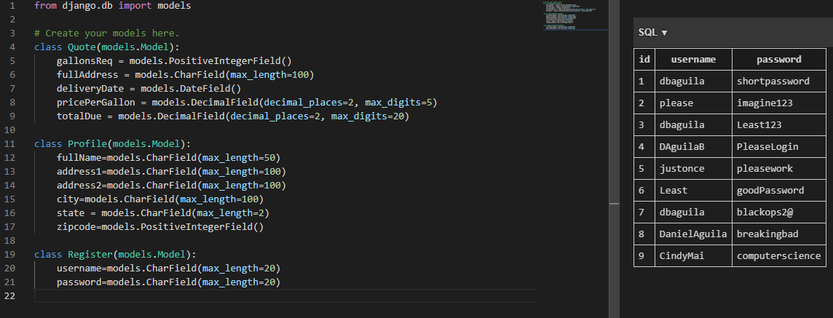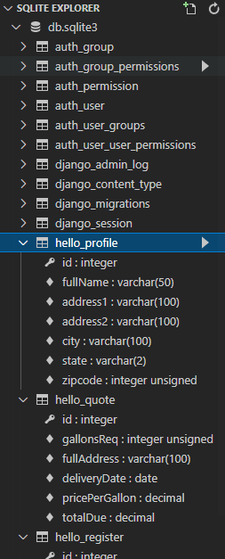
3. Code Coverage:

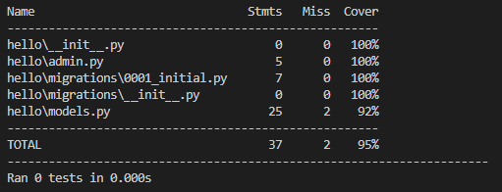

1. **Responsibilities:**

Daniel Aguila- UserCredentials

Cindy Mai- ClientInformation

Jan Tamayo- Fuel Quote